

Functional Requirements Document (FRD)
  - Banner Wholesale Grocers – Tax Customization

Copyright© 2018, Oracle and/or its affiliates. All rights reserved.
Any reproduction or distribution of any part of this document without the prior written permission of Oracle + NetSuite is strictly prohibited.
The information included in this document is confidential and proprietary information of Oracle + NetSuite.
Version: August 8, 2018

Oracle + NetSuite
2955 Campus Drive, Suite 100
San Mateo, CA. 99403-2511

Project Information
Implementation Name | J876842 Banner Wholesale Grocers | Change Order 002
Customer Name (Number) | 4679428 Banner Wholesale Grocers
Job Name (Number) | J876842
Document Owner | Myr Villa
Functional Consultant | Myr Villa
Technical Consultant | Ilan Daniele

Document Version History
Rev | Date | Author(s) | Change Summary
0.1 | 09/22/2022 | Myr Villa | Initial draft
0.2 | 09/23/2022 | Ilan Daniele | First Revision

Table of Contents
1 Introduction 4
2 Business Requirements 4
3 Solution Overview 4
4 Assumptions 7
5 Sample Test cases 7
6 Acceptance 9

Introduction
Banner Wholesale Grocers is a family-owned business to provide over 4,000 products which preferred destination for grocery stores, supermarket, retail shops, restaurants, and other wholesale companies.
Banner Wholesale seeks additional functionality on their SuiteCommerce webstore. They require a customization to compute tax rate amounts depending on different items, on the checkout process, which will show the total amount of tax applied.

Business Requirements
The document will cover the following customization:
Create a customization for SuiteCommerce Standard site that will display a warning message on the PDP and checkout section, and modify checkout section in order to apply certain taxes depending if the product is a water bottle product and if the customer is marked as taxable or not.
The product will be marked as taxable depending on a checkbox on its record set by Banners Wholesale Grocers.
The customer will be taxable depending on a checkbox on its record set by Banners Wholesale Grocers.
Before submitting this order, these taxes should be applied into the sales order, and there will be taxes added from an ERP Script being run after submit.

Solution Overview
This solution will cover the following conditions that Banner Wholesale Grocers have in determining that a web order is eligible to compute tax rate amount for different items. It will follow next steps in order to get it:
- A taxable customer logs into webstore to purchase products:
We will look onto the customer record to see the checkbox “customer tax exempt” marked or not, depending if the customer should pay for the tax or not.
- Customer selects a plastic water bottle item:
A Plastic Water Bottle item is defined by the Tax Group Field (Field ID: custitem_nscs_tax_code) on the Item Record. The field is populated as “IL_Cook_Chicago - BOTTLED WATER”.
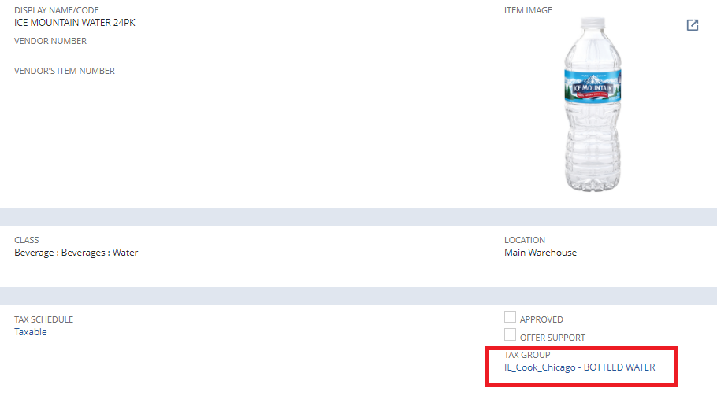
An item that is not classified as Plastic Water Bottle is defined by the Tax Group Field (Field ID: custitem_nscs_tax_code) on the Item Record. The field must not be populated as “IL_Cook_Chicago - BOTTLED WATER”.

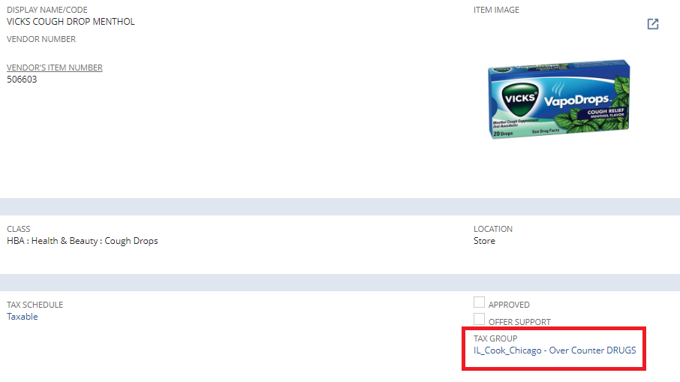
When the user views the Item in the Product Details Page, if he is taxable on it’s record, the client should add on description information about the water tax rate amount to be added upon checkout:
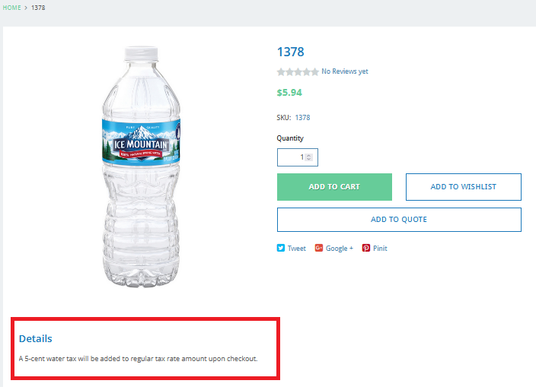
Also, if the product and the customer are taxable, a warning message should be added to the PDP displaying:
“This item might include specific water bottle taxes”
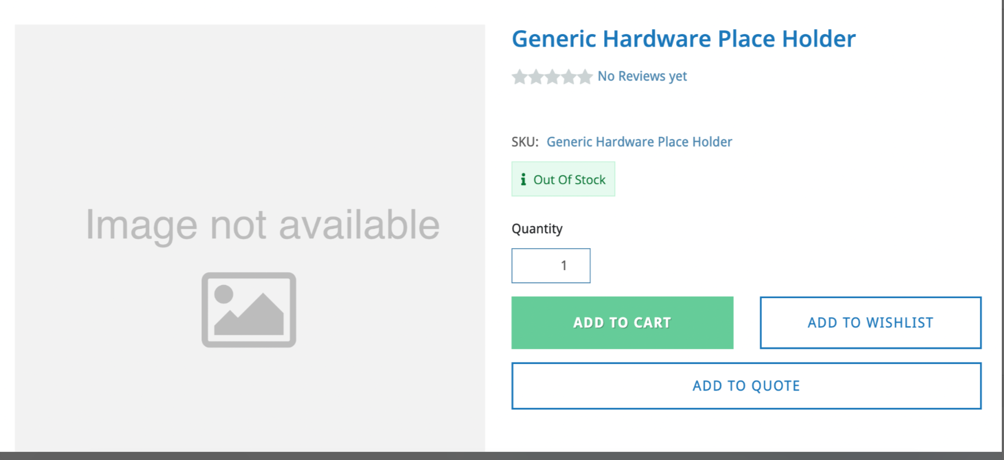
Looking like “Out of Stock” message on this screen.

- Taxable customer adds plastic water bottle to the cart
Screenshot of checkout to show the new “Water Tax” field on the Summary section to show the water tax rate amount when the item is plastic water bottle.
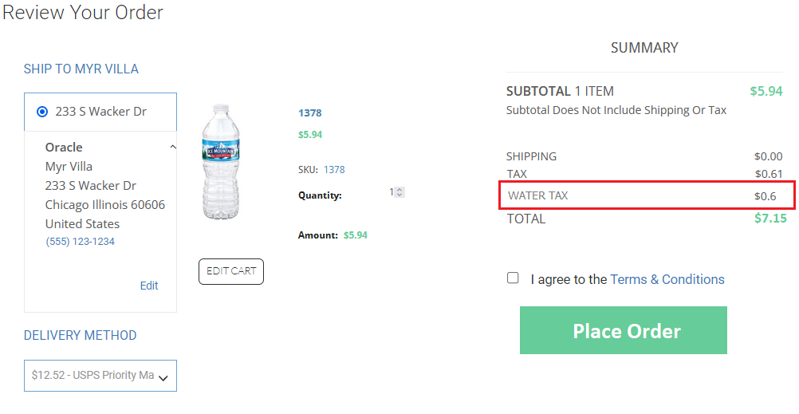

Option:
A warning message like the one displayed on the PDP should be added to the Checkout section.


- Customer places order upon completion of checkout and water bottle tax rate amount computation should be added to the tax native tax amount in Sales Order.
Agregar un cartelito Amarillo que diga, este tanto es el tax, cantidad?
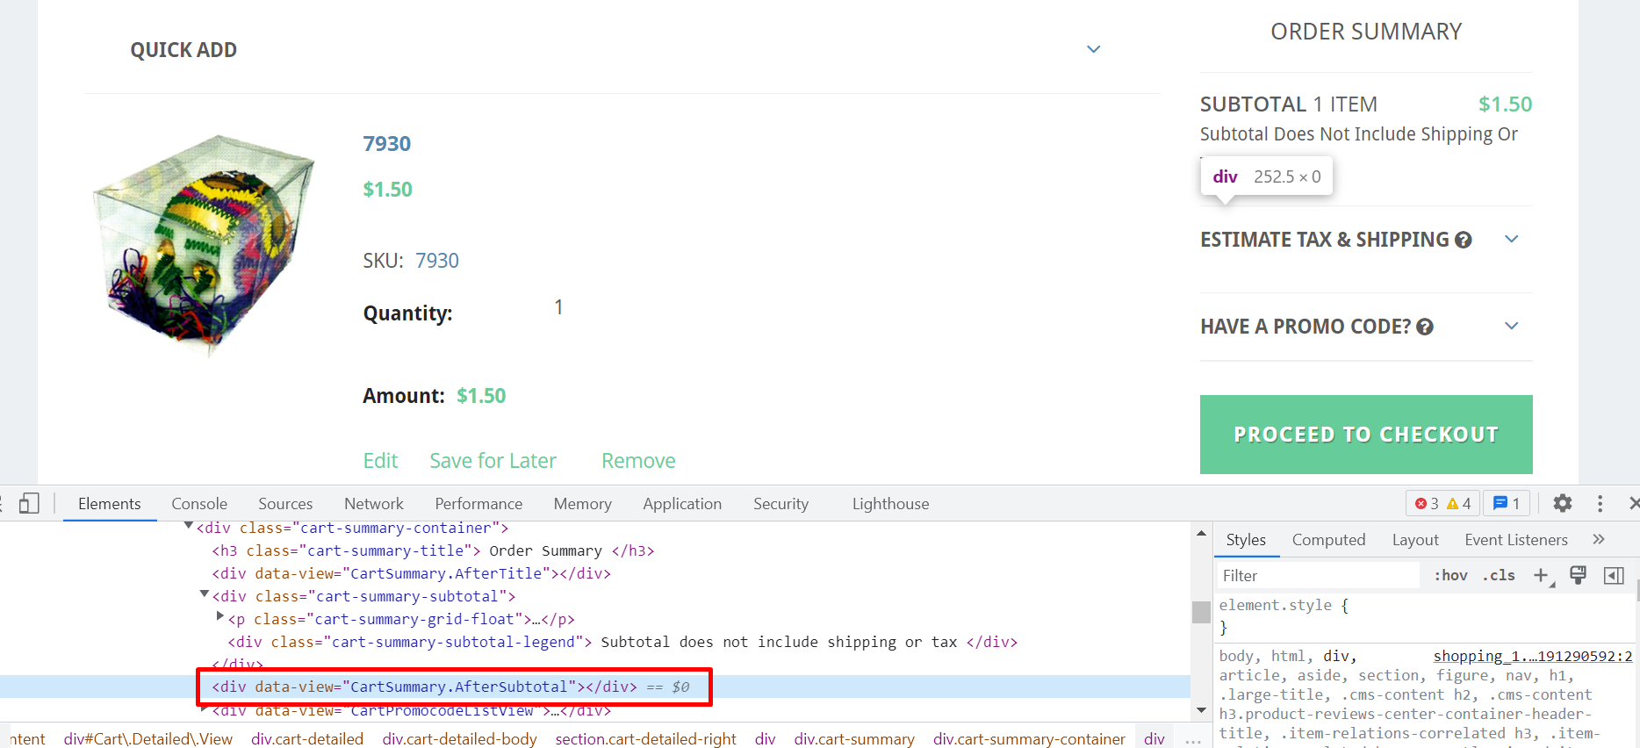
Ahí meter el tax.

What happens when we have multiple bottles of water? Do the taxes sum up? Yes. The taxes do sum up.
Condition cases for regular items and non-regular items? We assume NetSuite handles it.
Where do we get the tax amount from for the bottle of water? Where is this value going to be set 0.5 cents? Coordinar con Hayden por script deployment.

Assumptions
- Plastic water bottles taxes will be handled into our customization, and Banner Wholesale Grocers will fill up the necessary data.
- Customer will submit description information on products on taxes amount on water bottles.
- All customers are classified either water tax exempt or not. Banner Wholesale Grocers will provide a checkbox that indicates if a customer is tax exempt or not. Banner should be precise and set all the customers to taxable or not depending if they are in Chicago or not. If customer is in Chicago, Banner Wholesale Grocers is in charge of setting it’s tax exempt checkbox to true. Also, if the customer moves, Banner is responsible for updating so. When the customer changes the shipping information (e.g., Chicago to California), Banner Wholesale Team needs to manually handle the issuing credit for water tax they should not be paying for. Conversely, if a customer moves to Chicago, Banner Wholesale team will manually handle issuing water tax to that customer.
- Regular and non-regular item taxes will be handled by NetSuite. Non-regular and regular items follow the standard tax amount computation in the NetSuite.

Sample Test cases

Tests for Banner Wholesale Grocers Users
TEST 1: Sales order has items subject to Water Tax, Customer is not water tax exempt.
- Test item has Tax Group of “IL_Cook_Chicago - BOTTLED WATER” on the Item Record.
- The “Water Tax Exempt” checkbox should be unchecked on the Customer Record.
- Login to webstore and search for the item. An information about the added water tax rate amount is defined under Description section of the Product Details Page.
- Add item to cart and proceed to checkout.
- Verify the Water Tax amount should appear on the Summary section
- Submit order and check the tax computation in the Sales Order.
TEST 2: Sales order has items subject to Water Tax, Customer is water tax exempt.
- Test item has Tax Group of “IL_Cook_Chicago - BOTTLED WATER” on the Item Record.
- The “Water Tax Exempt” checkbox should be checked in the Customer Record.
- Login to webstore and search for the item. An information about the added water tax rate amount is defined under Description section of the Product Details Page.
- Add item to the cart and proceed to checkout.
- In the Summary section, verify the Water Tax amount is “$0.00”. (Better not to appear)
- Submit order and check the tax amount value in the Sales Order.

TEST 3: Sales order has no items subject to Water Tax.
- Test item is not classified as Tax Group of “IL_Cook_Chicago - BOTTLED WATER” on the Item Record.
- Login to webstore and search for the item. Add item to the cart and proceed to checkout.
- In the Summary section, verify the Water Tax amount is “$0.00”. (Better not to appear)
- Submit order and check the tax amount value in Sales Order.

Acceptance
Oracle + NetSuite Professional Services and Customer are in agreement that the information documented above is accurate and representative of the customer’s business needs. This document will act as the basis for all subsequent implementation activities.
Delivery Date:
Document Version:0.2

Oracle + NetSuite Acceptance
Action | Name | Title | Signature | Date
Accepted By | Myr Villa | Functional Consultant
Accepted By | Ilan Daniele | Technical Consultant

Customer Acceptance
Action | Name | Title | Signature | Date
Accepted By | Jeff Harigan | Project Manager

